Welcome to the thingSoC® Grovey ADC
The TSOC_GROVEY_ADC is a four(4) port Analog-to-Digital converter, based on the ADS1015/1115 chip, in an Embedded Module format for the new thingSoC, Internet of Things open source hardware standard.
Getting Started :
The TSOC_GROVEY_ADC provides four (4) Analog-to-Digital ports on four(4) Grove compatible connectors. You can use the TSOC_GROVEY_ADC when :
- When you need to do input 5.0 Volt level sensors to a 3.3V processor.
- When you need more resolution than the 3.3V processor can provide.
- When you need anti-aliasing input conditioning on your analog inputs.
The TSOC_GROVEY_ADC is an open source hardware project from PatternAgents, LLC,
and you are free to download the schematics, layouts, gerbers, BOMs, etc and build your own boards if you wish.
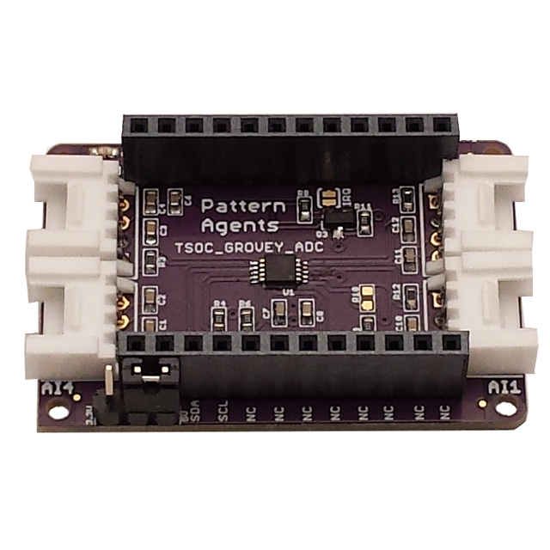

Safe Handling Precautions :
1) Always remove/unplug all power before inserting or removing peripherals.
2) Always ground yourself by touching a ground point before handling your boards.
3) Use a static safe bag when transporting your TSOC_GROVEY_ADC board.
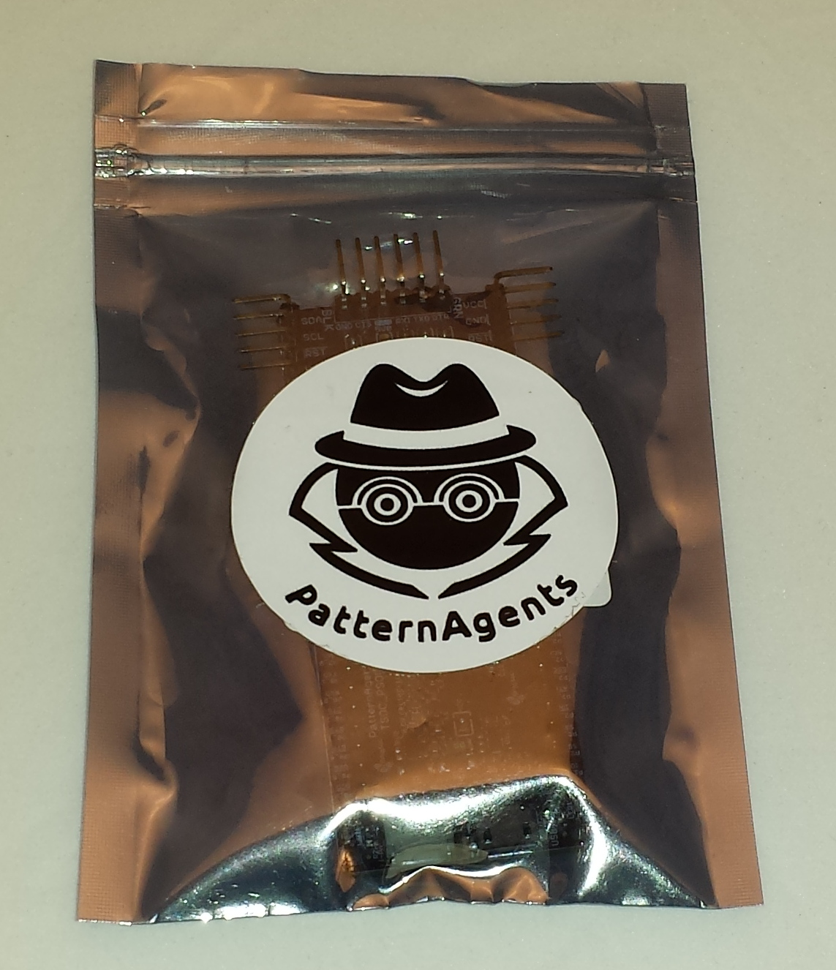

Adding Grove Peripherals :
The TSOC_GROVEY_ADC board supports Grove peripherals.
1) Grove connectors are polarized, and can only be plugged in one way.

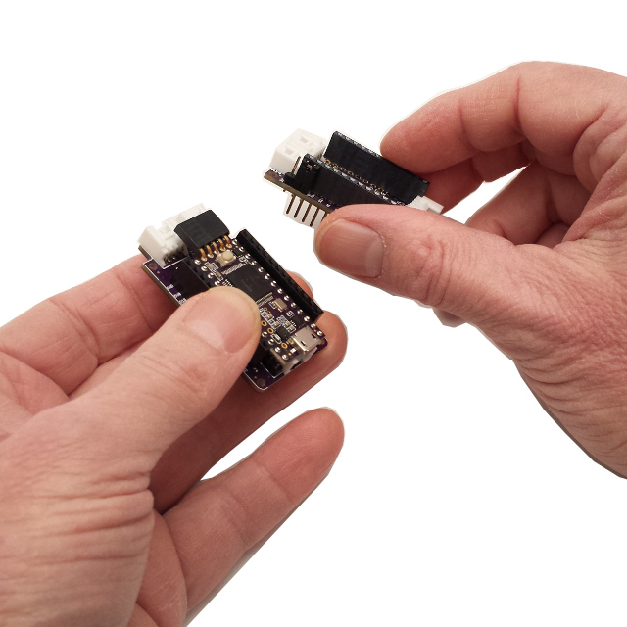

Adding Mikrobus Peripherals :
The TSOC_GROVEY_ADC board supports Grove peripherals and can interoperate with Mikrobus peripherals.
1) Make sure to align the SQUARE/CUT edges of the Mikrobus board together to insure that
the polarity is correct. Push down evenly to seat the boards in the socket.
2) Note that the "stacking pins" are somewhat longer by design, and there will be some
extra space between the boards when using stacking connectors.
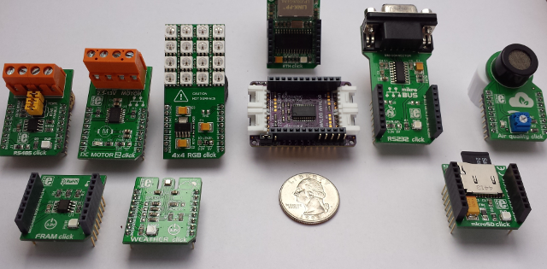
For more information and examples :

Complete documentation, including schematics, layouts, gerbers, and Bill of Materials (BOM) are available on the thingSoC website at :
https://github.com/thingSoC/TSOC_GROVEY_ADC/tree/master/TSOC_GROVEY_ADC

There is also a project Wiki available for asking questions and more information at :
https://github.com/thingSoC/TSOC_GROVEY_ADC/wiki

thingSoC® Grovey ADC Features :
The TSOC_GROVEY_ADC is a low cost, embeddable module featuring an NXP PCA9546A device :
- ADS1015 (12 bits) or ADS1115 (16 bits)
- 0 Hz to 400KHz I2C Bus Speed
- 3.3 Volt or 5.0 Volt operation
- Optional Active Low Reset Line
- Low Standby current
- Builtin ESD protection
- ADC (4 Channels)
- Power LED
- thingSoC Compliant Module
- Mikrobus Compatible Module
- Support SeeedStudio Grove Peripherals

